**SE-Assignment-5**

Installation and Navigation of Visual Studio Code (VS Code) Instructions: Answer the following questions based on your understanding of the installation and navigation of Visual Studio Code (VS Code). Provide detailed explanations and examples where appropriate.

Questions:

1. Installation of VS Code:
   * Describe the steps to download and install Visual Studio Code on Windows 11 operating system. Include any prerequisites that might be needed.

To install Visual Studio Code on Windows 11:

1. **Prerequisites:** Ensure Windows 11, internet access, and administrative privileges.
2. **Download:** Visit the VS Code website, [https://code.visualstudio.com/] download the installer (VSCodeSetup-{version}.exe).

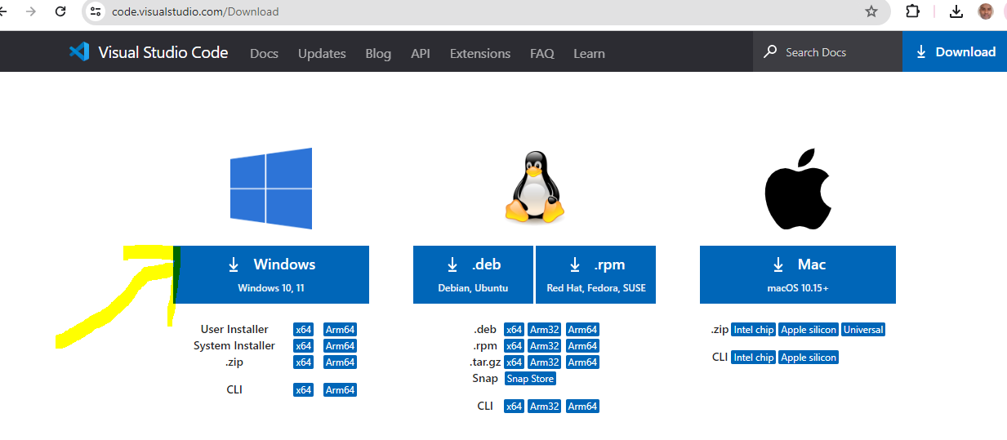

1. **Run Installer:** Double-click the downloaded file.

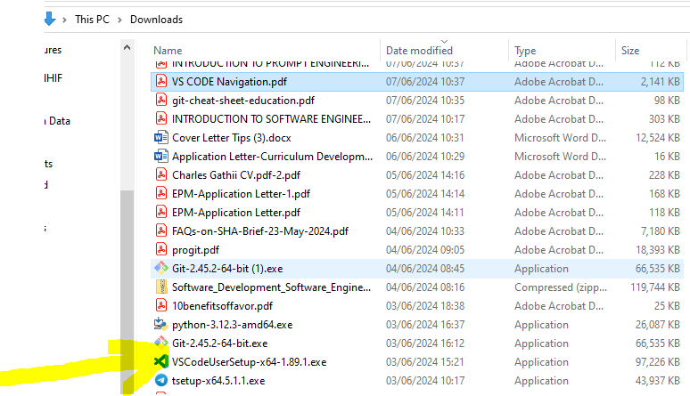

1. **Installation Steps:** Follow prompts to accept license, choose installation location, and complete installation.
2. **Verification:** Confirm installation by locating and launching VS Code from the Start menu.
3. **Optional:** Enhance functionality by installing extensions via VS Code's Extension Marketplace.

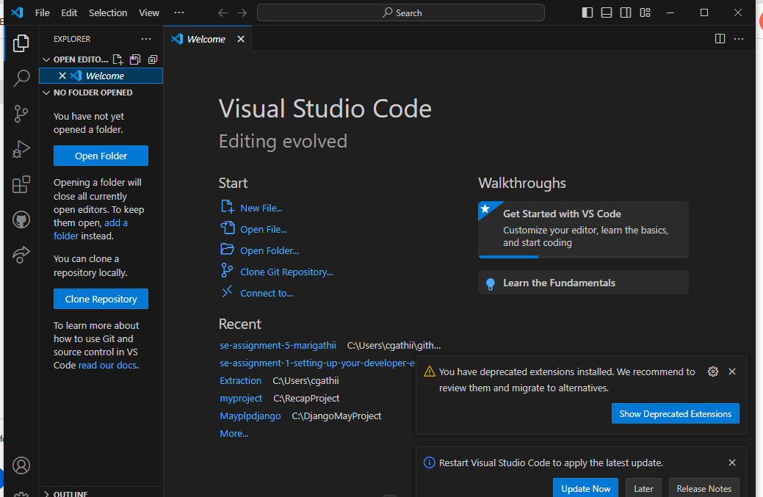

1. First-time Setup:
   * After installing VS Code, what initial configurations and settings should be adjusted for an optimal coding environment? Mention any important settings or extensions.

**There is need to ensure installation of necessary extensions such as such as**

* + **Python:** Microsoft’s Python extension for IntelliSense, linting, and
  + **IntelliCode:** AI-assisted code completions.

1. User Interface Overview:
   * Explain the main components of the VS Code user interface. Identify and describe the purpose of the Activity Bar, Side Bar, Editor Group, and Status Bar.

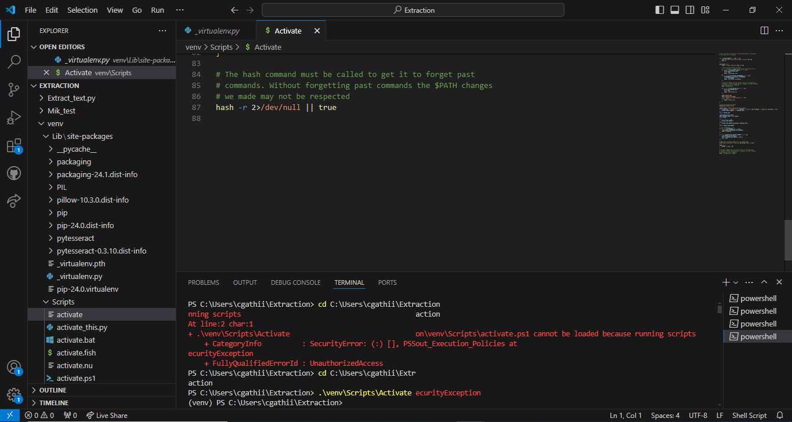

Visual Studio Code (VS Code) has a user-friendly interface designed to enhance productivity for developers. Here's an overview of its main components:

1. **Activity Bar:**
   * **Purpose:** The Activity Bar is located on the far-left side of the VS Code window. It contains icons representing different activities or views such as Explorer, Search, Source Control, Debug, and Extensions.
   * **Description:** Clicking on any of these icons switches the main focus of VS Code to that particular activity or view. For example, clicking on the Explorer icon opens the file explorer, while clicking on the Debug icon opens the debug view.
2. **Side Bar:**
   * **Purpose:** The Side Bar is located adjacent to the Activity Bar and typically shows additional information and functionality related to the current activity or view selected from the Activity Bar.
   * **Description:** For instance, when the Explorer icon is selected from the Activity Bar, the Side Bar displays the file explorer tree. Similarly, selecting the Debug icon from the Activity Bar shows debugging-related panels in the Side Bar.
3. **Editor Group:**
   * **Purpose:** VS Code allows users to work with multiple files simultaneously by splitting the editor area into multiple columns (editor groups).
   * **Description:** Each column within the editor area is called an Editor Group. You can open different files or even the same file in different editor groups, making it easier to compare and edit code side by side.
4. **Status Bar:**
   * **Purpose:** Located at the bottom of the VS Code window, the Status Bar provides information about the current state of the editor and the project being worked on.
   * **Description:** It includes various indicators such as the current branch in Git, the language mode of the current file, line and column numbers of the cursor position, and the number of lines in the file. It also houses the notification area and various optional features like the language mode switcher and indentation settings
5. Command Palette:
   * What is the Command Palette in VS Code, and how can it be accessed? Provide examples of common tasks that can be performed using the Command Palette.

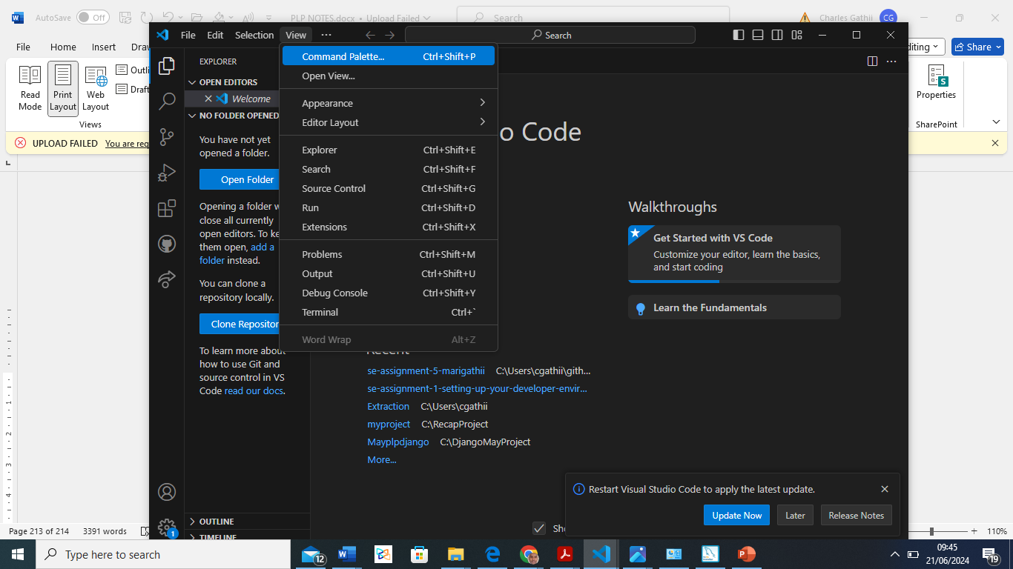

The Command Palette is an indispensable tool in VS Code, enabling quick and efficient execution of a wide range of tasks, improving productivity and workflow.

**Accessing the Command Palette**

The Command Palette can be accessed in several ways:

* **Keyboard Shortcut:** Press Ctrl + Shift + P (Windows/Linux) or Cmd + Shift + P (macOS).
* **Menu:** Go to the menu bar at the top, click on View, and then select Command Palette....

**Common Tasks Performed Using the Command Palette**

Here are some examples of common tasks that can be performed using the Command Palette:

1. **Opening Files:**
   * You can quickly open any file in your project by typing Open File.
2. **Changing Language Mode:**
   * If you need to change the language mode of the current file (e.g., from JavaScript to TypeScript), you can type Change Language Mode.
3. **Running Commands:**
   * You can run various commands, such as Run Task, Toggle Terminal, or Format Document, by typing the respective command.
4. **Installing Extensions:**
   * To install new extensions, you can type Extensions: Install Extensions and search for the desired extension.
5. **Git Commands:**
   * Git commands like Git: Commit, Git: Pull, and Git: Push can be executed directly from the Command Palette.
6. **Managing Settings:**
   * You can open settings and tweak configurations by typing Preferences: Open Settings.
7. **Launching Debugger:**
   * Start debugging a project by typing Debug: Start Debugging.
8. **Navigating to Symbols:**
   * Jump to specific symbols in your code by typing Go to Symbol in Workspace or Go to Symbol in File.
9. **Snippet Management:**
   * Insert code snippets or manage them by typing Insert Snippet or Configure User Snippets.
10. **Window Management:**
    * Commands like View: Split Editor, View: Toggle Full Screen, and View: Toggle Zen Mode help in managing the workspace layout.

**Example Walkthrough**

Suppose you want to format the document you are currently working on:

1. Press Ctrl + Shift + P to open the Command Palette.
2. Start typing Format Document.
3. Select the Format Document option from the list that appears.
4. Extensions in VS Code:
   * Discuss the role of extensions in VS Code. How can users find, install, and manage extensions? Provide examples of essential extensions for web development.

**Role of Extensions in VS Code**

Extensions in Visual Studio Code (VS Code) play a crucial role in enhancing the functionality and customization of the editor. They allow users to add new features, themes, debuggers, and tools to improve their coding experience and productivity. Extensions can support various programming languages, frameworks, and workflows, making VS Code a highly versatile and powerful tool.

**Finding, Installing, and Managing Extensions**

**Finding Extensions:**

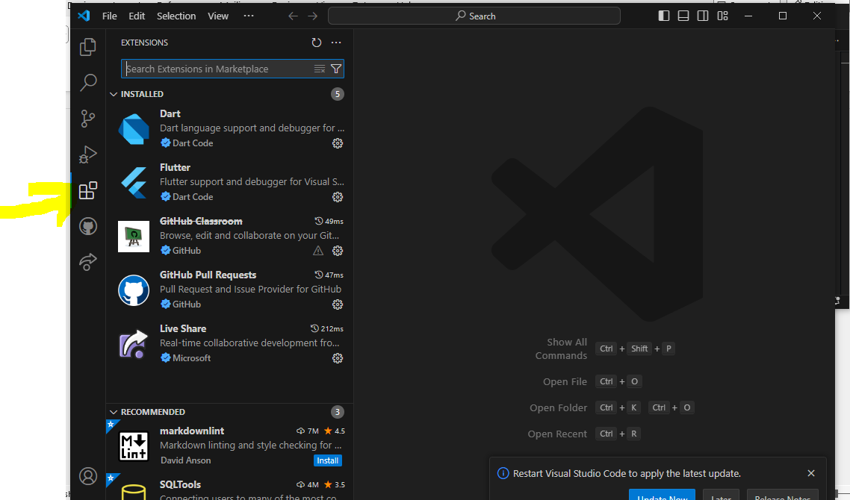

1. **Within VS Code:**
   * Open VS Code.
   * Click on the Extensions icon in the Activity Bar on the side of the window (or press Ctrl+Shift+X).
   * Use the search bar at the top of the Extensions view to find specific extensions or browse through categories.

• In the Extensions view, search for the desired extension.

• Click the "Install" button next to the extension name.

* + • Reload or restart VS Code if prompted

• Installing **Extensions:**

* To install new extensions, you can type Extensions: Install Extensions and search for the desired extension.

• Git **Commands:**

* Git commands like Git: Commit, Git: Pull, and Git: Push can be executed directly from the Command Palette

1. Integrated Terminal:
   * Describe how to open and use the integrated terminal in VS Code. What are the advantages of using the integrated terminal compared to an external terminal?

**Opening and Using the Integrated Terminal in VS Code**

**Opening the Integrated Terminal:**

1. **Via Menu:**
   * Click on the View menu in the top menu bar.
   * Select Terminal from the dropdown menu.
2. **Using Keyboard Shortcut:**
   * Press Ctrl + (backtick) to quickly open or toggle the terminal.
3. **Via Command Palette:**
   * Press Ctrl + Shift + P to open the Command Palette.
   * Type Toggle Terminal and select the command from the list.

**Using the Integrated Terminal:**

1. **Running Commands:**
   * Type your desired commands as you would in any terminal (e.g., cd, ls, git, npm).
2. **Multiple Terminals:**
   * Click the + icon in the terminal panel to open a new terminal instance.
   * Use the dropdown menu to switch between different terminal instances.
3. **Splitting Terminals:**
   * Click the split terminal icon (which looks like a split screen) to create side-by-side terminal instances.
4. **Customization:**
   * Open Settings via File > Preferences > Settings and search for terminal.integrated.shell to set a custom shell (e.g., PowerShell, Command Prompt, Git Bash, or WSL).
5. **Terminal Navigation:**
   * Use Ctrl + Page Up/Page Down to navigate between terminal instances.
   * Use the terminal dropdown menu to select and manage terminals.

**Advantages of Using the Integrated Terminal Compared to an External Terminal**

1. **Convenience and Efficiency:**
   * **Single Workspace:** The integrated terminal allows you to stay within the VS Code environment, avoiding context switching between the editor and an external terminal.
   * **Quick Access:** Easily open the terminal with a keyboard shortcut or from the menu for rapid command execution.
2. **Context Awareness:**
   * **Project Root:** The terminal opens in the root directory of your project by default, simplifying navigation and command execution within your project context.
   * **Editor Integration:** Seamlessly integrates with other VS Code features like debugging, allowing for streamlined workflows.
3. **Customization and Extension:**
   * **Custom Shells:** Configure the terminal to use any shell that suits your workflow (e.g., PowerShell, Command Prompt, Git Bash, WSL).
   * **Extensions:** Enhance terminal functionality with VS Code extensions, such as improved syntax highlighting and command history management.
4. **Visual Integration:**
   * **Side-by-Side Viewing:** Split the terminal to run multiple commands simultaneously or view terminal output alongside your code.
   * **Consistent Appearance:** Shares the same color theme and font settings as the editor, providing a cohesive look and feel.
5. **Task Automation:**
   * **Tasks:** Define and run tasks directly from the terminal. VS Code tasks can automate build scripts, test commands, and other repetitive tasks, integrating them into your workflow.

Using the integrated terminal in VS Code enhances productivity by streamlining the development process, reducing the need to switch between applications, and providing a cohesive development environment.

1. File and Folder Management:
   * Explain how to create, open, and manage files and folders in VS Code. How can users navigate between different files and directories efficiently?

**File and Folder Management in VS Code**

**Creating Files and Folders:**

1. **Via Explorer:**
   * Right-click in the Explorer pane, select New File or New Folder, enter the name, and press Enter.
2. **Using Command Palette:**
   * Press Ctrl + Shift + P, type New File or New Folder, enter the name, and press Enter.
3. **Keyboard Shortcuts:**
   * Create a new file with Ctrl + N, save with Ctrl + S.

**Opening Files and Folders:**

1. **Via Explorer:**
   * Double-click a file or right-click a folder and select Open Folder.
2. **Using Command Palette:**
   * Press Ctrl + Shift + P, type Open File or Open Folder, and navigate to the desired item.
3. **Drag and Drop:**
   * Drag files or folders from your file system into the VS Code window.

**Managing Files and Folders:**

1. **Renaming:**
   * Right-click the item in the Explorer pane, select Rename, and enter the new name.
2. **Moving:**
   * Drag and drop the item within the Explorer pane, or use cut (Ctrl + X) and paste (Ctrl + V).
3. **Deleting:**
   * Right-click the item and select Delete, then confirm.
4. **Multi-Select:**
   * Use Shift + Click or Ctrl + Click to select multiple items for bulk actions.

**Efficient Navigation:**

1. **File Explorer:**
   * Use the Explorer pane to navigate through your project's structure.
2. **Quick Open:**
   * Press Ctrl + P, type the file name, and select from the list.
3. **Breadcrumb Navigation:**
   * Click on any part of the breadcrumb at the top to navigate to that directory.
4. **Go to Definition:**
   * Right-click on a function/variable/class, select Go to Definition or press F12.
5. **Open Editors View:**
   * View and switch between open files in the Open Editors pane.
6. **Tab Management:**
   * Use tabs at the top for switching files, or Ctrl + Tab to cycle through open files.
7. **Search:**
   * Press Ctrl + Shift + F to search for text within your entire project.
8. Settings and Preferences:
   * Where can users find and customize settings in VS Code? Provide examples of how to change the theme, font size, and keybindings.

**Settings and Preferences in VS Code**

Users can find and customize settings in Visual Studio Code (VS Code) through the Settings menu. Here’s how to locate and adjust various settings, including changing the theme, font size, and keybindings

* Access **Settings:** File > Preferences > Settings, Ctrl +,, or Ctrl + Shift + P then type Open Settings.
* Change **Theme:** Search for Color Theme in settings or use Ctrl + Shift + P > Preferences: Color Theme.

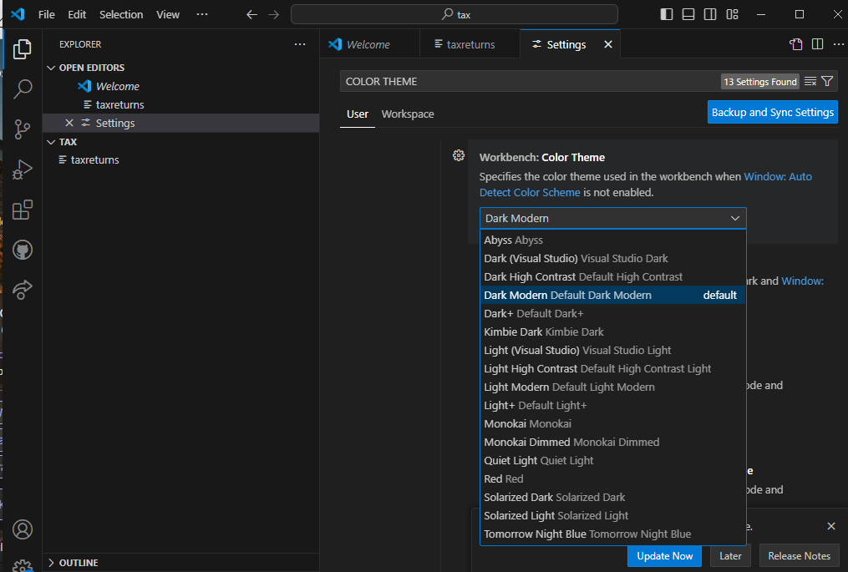

* Change **Font Size:** Search for font size in settings or edit settings.json with "editor.fontSize": value.

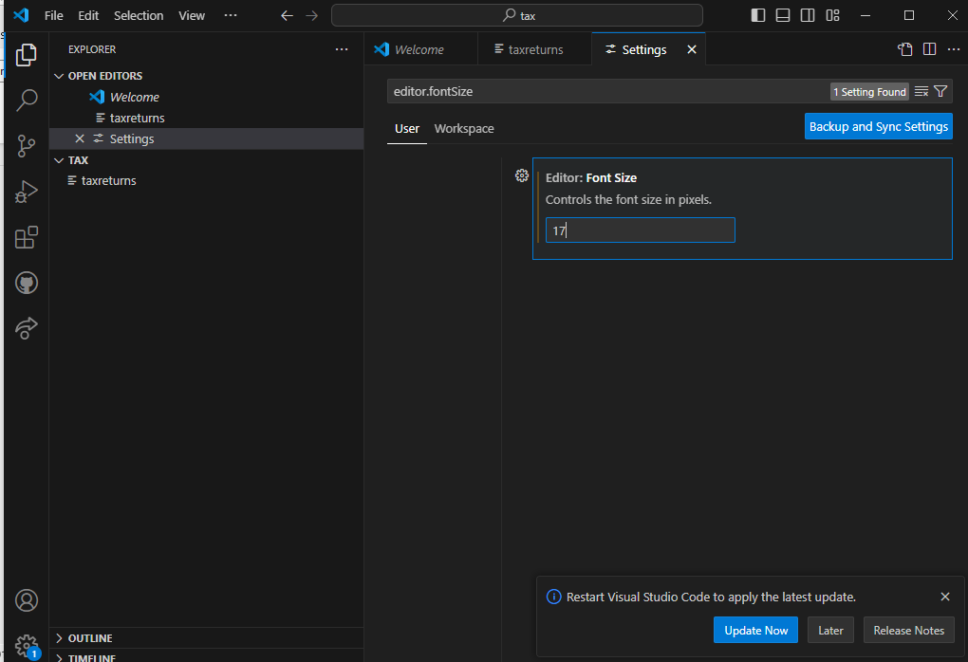

* Change **Keybindings:** Open Keyboard Shortcuts with Ctrl + K, Ctrl + S or via the menu, then customize keybindings or edit keybindings.json

1. Debugging in VS Code:
   * Outline the steps to set up and start debugging a simple program in VS Code. What are some key debugging features available in VS Code?

**Setting Up and Starting Debugging in VS Code**

**Step-by-Step Setup for Debugging a Simple Program**

1. **Open Your Project:**
   * Launch VS Code.
   * Open your project folder by going to File > Open Folder and selecting your project directory.
2. **Create or Open the Program File:**
   * Create a new file or open an existing file with your code. For example, a simple Python file example.py or a JavaScript file example.js.
3. **Add Debug Configuration:**
   * Go to the Run and Debug view by clicking the Run icon in the Activity Bar on the side or pressing Ctrl + Shift + D.
   * Click on create a launch.json file link if it’s your first time setting up debugging. This opens a launch.json file with some default configurations based on the language you are using.
   * Choose the appropriate environment (e.g., Python, Node.js) from the list.
4. **Set Breakpoints:**
   * Click in the gutter (left margin) of the editor next to the line number where you want to set a breakpoint. A red dot will appear indicating the breakpoint.
5. **Start Debugging:**
   * In the Run and Debug view, click the green play button (Start Debugging) or press F5.

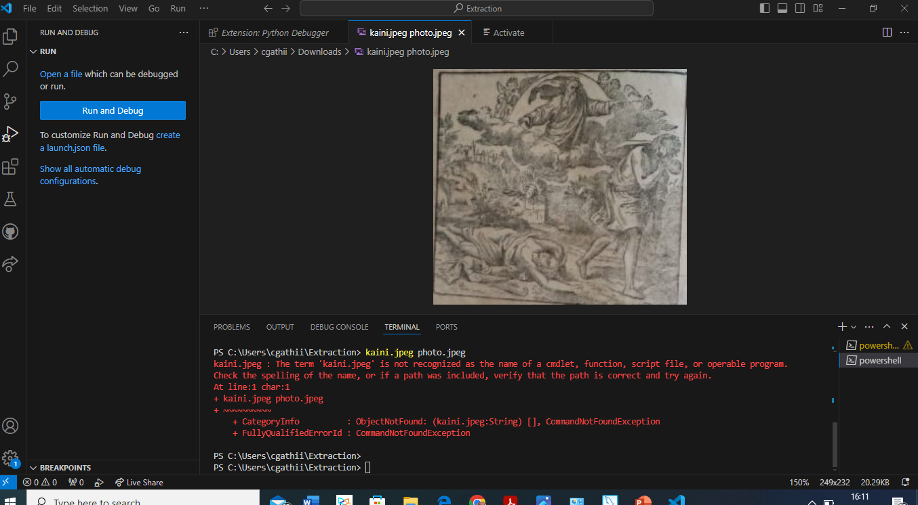

1. Using Source Control:
   * How can users integrate Git with VS Code for version control? Describe the process of initializing a repository, making commits, and pushing changes to GitHub.

**Step 1: Setting Up Git in VS Code**

1. **Install Git:** Ensure that Git is installed on your system. You can download it from the [official Git website](https://git-scm.com/downloads).
2. **Verify Installation:** Open a terminal and type git --version to verify that Git is installed correctly.

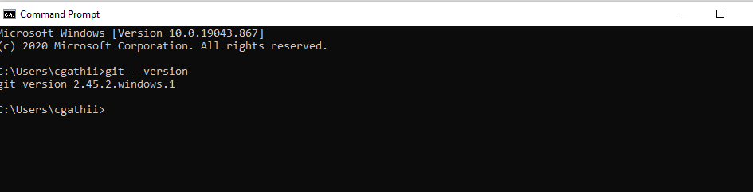

**Step 2: Initializing a Repository**

1. **Open VS Code:** Open your project folder in VS Code.

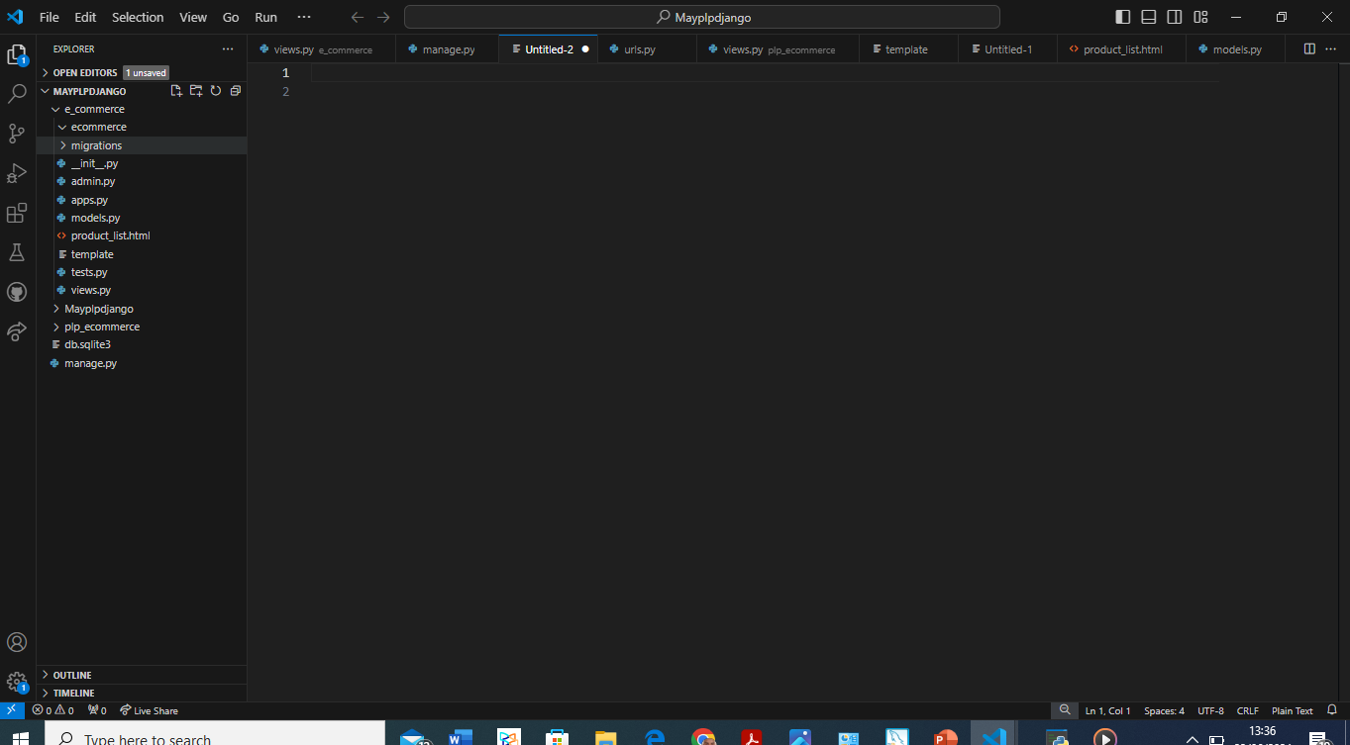

1. **Initialize Repository:**
   * Open the Source Control view by clicking on the Source Control icon in the Activity Bar on the side of the window (or press Ctrl + Shift + G).
   * Click on the Initialize Repository button. This will create a new Git repository in your project folder.

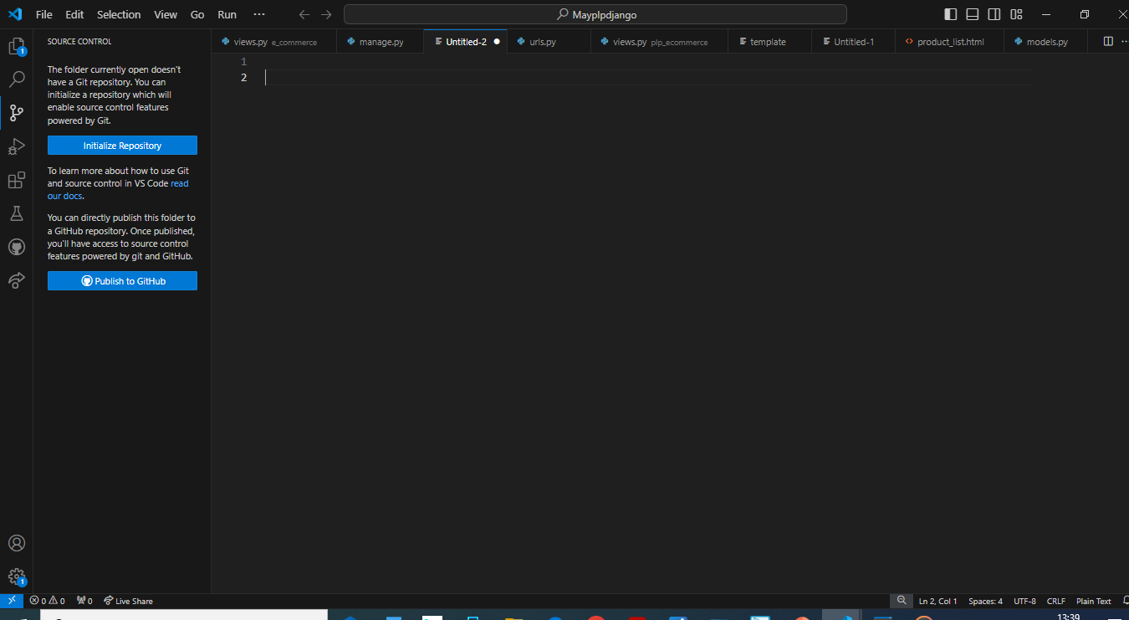

**Step 3: Making Commits**

1. **Stage Changes:**
   * Make changes to your files.
   * In the Source Control view, you will see a list of changed files. Hover over the changes you want to commit and click the + icon to stage them. Alternatively, click the Stage All Changes button.

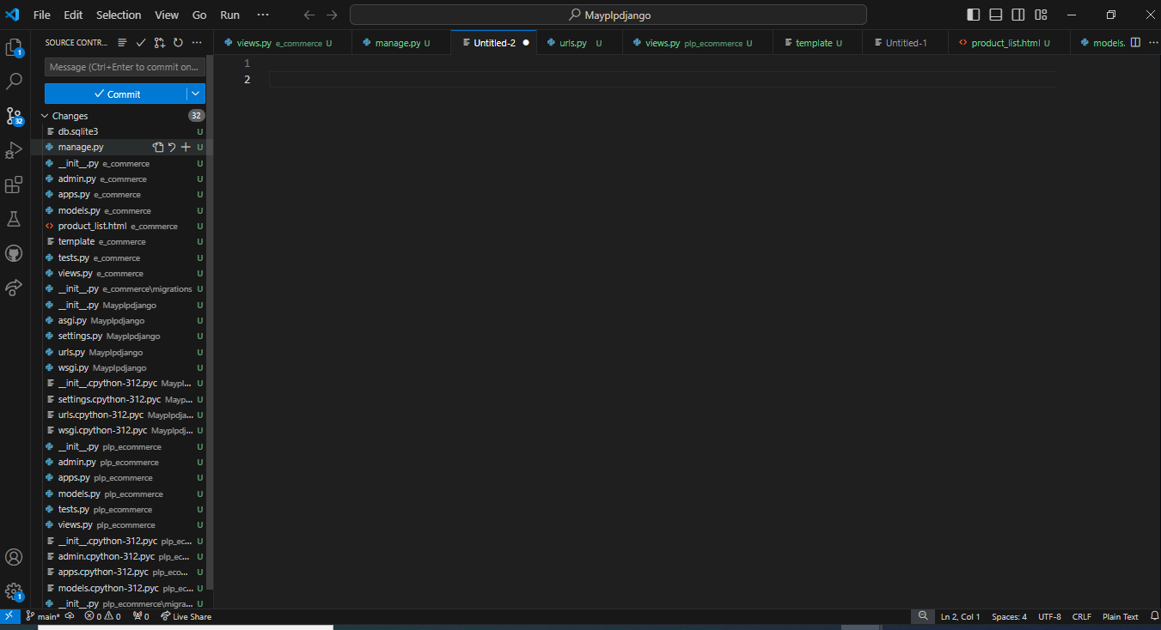

1. **Commit Changes:**
   * After staging the changes, you need to commit them. Enter a commit message in the input box at the top of the Source Control view.
   * Click the checkmark icon or press Ctrl + Enter to commit the changes.

**Step 4: Connecting to GitHub**

1. **Create a Repository on GitHub:**
   * Go to GitHub and create a new repository. Make note of the repository URL.
2. **Add Remote Repository:**
   * In VS Code, open the terminal (you can do this by selecting Terminal > New Terminal from the menu or pressing Ctrl + ).
   * Add the remote repository URL with the following command:

bash

Copy code

git remote add origin <https://github.com/your-username/your-repository.git>

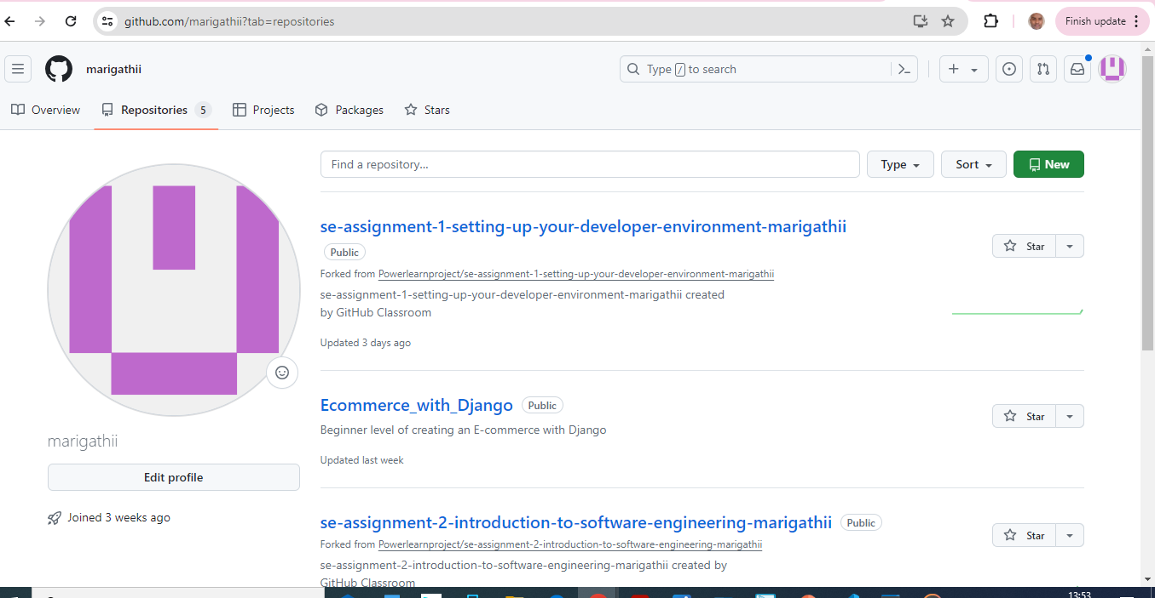

**Step 5: Pushing Changes to GitHub**

1. **Push Changes:**
   * To push your commits to GitHub, use the following command in the terminal:

bash

Copy code

git push -u origin master

* + This command pushes the changes to the master branch of the remote repository. If your repository uses a different default branch (e.g., main), replace master with main.

**Step-by-Step Summary**

1. **Initialize Repository:**
   * Open-Source Control view (Ctrl + Shift + G).
   * Click Initialize Repository.
2. **Stage and Commit Changes:**
   * Stage changes by clicking the + icon.
   * Enter a commit message and commit changes.
3. **Connect to GitHub:**
   * Create a repository on GitHub.
   * Add the remote repository in the terminal:

bash

Copy code

git remote add origin https://github.com/your-username/your-repository.git

1. **Push Changes:**
   * Push commits to GitHub using:

bash

Copy code

git push -u origin master

By following these steps, you can effectively manage your project’s version control using Git in VS Code and synchronize your changes with a GitHub repository.

Submission Guidelines:

* Your answers should be well-structured, concise, and to the point.
* Provide screenshots or step-by-step instructions where applicable.
* Cite any references or sources you use in your answers.
* Submit your completed assignment by 1st July